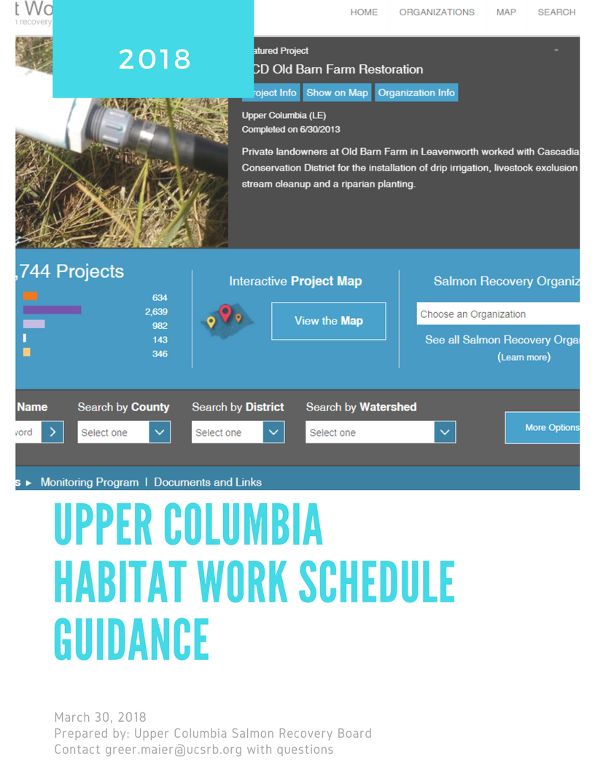

2018 HWS Deadlines and Trainings

Trainings
Training Opportunity #1- May 31, 2018
Training Opportunity #2- June 18, 2018

Deadlines
2018 New Proposed or Conceptual Projects- Due in HWS April 30, 2018
2017 Project Data entered and/or updated- June 30, 2018
Project status updated- July 30, 2018

Reports using updated HWS data
Implementation Schedule and Report (UCSRB)- August 31, 2018
State of the Salmon in Watersheds (GSRO)- October 1, 2018

Habitat Work Schedule Requirements
Adding New Projects: Sponsors seeking funding are required to create a project in HWS. This information is entered according to the grant timeline for the year, generally April-May. If you are applying for funding under SRFB please see the following guidance document provided by GSRO (http://waconnect.paladinpanoramic.com/File/10/2476).
Project Updates: UCSRB requests that sponsors routinely update the status of their projects in HWS (usually this is done through the WATs in August before completion of the Implementation Schedule).
Finalizing Project Information after Completion: After a project is completed UCSRB requires all project sponsors to complete required information in HWS. This step is very important because it allows the region, the state, funders and partners the ability to track habitat work in the region.

Creating a New Project in HWS
- First, ensure that the project is not already in HWS by searching for key words. If not, create a new project.
- Go to http://hws.ekosystem.us/ If you need login credentials, email pete.teigen@ucsrb.org.
- Once logged in, create a project by clicking in one of the two locations highlighted below:
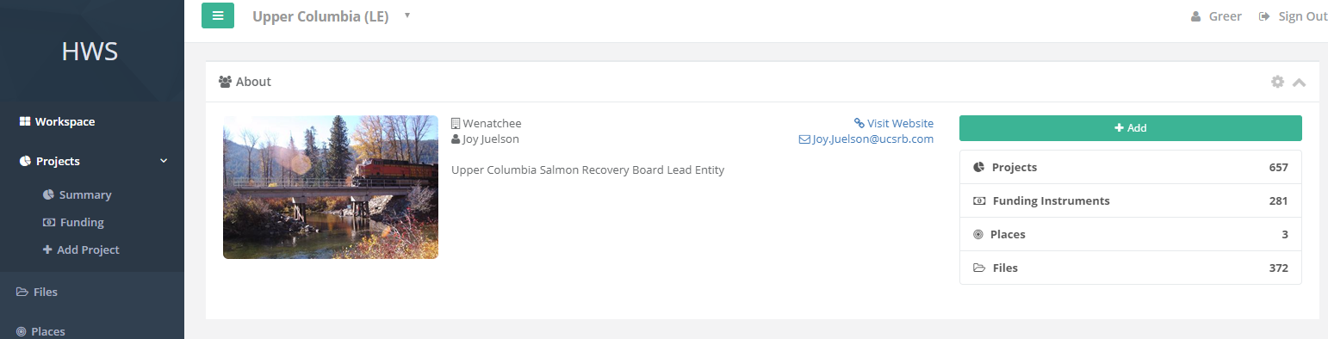
- In the Project Details tab
  - Do not use a template
  - Enter a Project Name Project name should include your sponsor name abbreviation and a clear, unique project name (e.g. CCNRD Nason Creek RM 2.3 Side Channel).
  - Enter a Project Number. Project number format is (subbasin code - start year - unique HWS ID). (subbasin code= Okanogan- 01, Methow-02, Entiat-03, Wenatchee-04, Other-05). The Unique HWS ID can be found in the ‘url’ of your project at the top of the page. Use the last number in the web address. An example for this project might be (01-2018-18703)
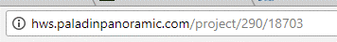

  - Enter a Project Category: only one of the following categories: Restoration, Acquisition, Acquisition/Restoration (Combination), Monitoring, or Non-Capital)
  - Enter Primary Status- **If the project is completed please refer to additional requirements below for project close-out.
  - Ignore Secondary Status
  - Enter Start date and (projected) End Date
  - Enter the Total Project Cost.
  - DO NOT create any project reporting codes at this time.
  - Hit Create Project

Linking your Project to PRISM
If you are applying for SRFB funding or have received SRFB funding and have a PRISM page you need to link your HWS project to PRISM. Once projects in HWS are linked to PRISM information on funding, metrics, and status will be populated in HWS and should make QAQC at project close out much easier.

I would suggest starting your project close-out by linking to PRISM and populating your HWS page with your PRISM information. Once you are done with your close-out you can “opt-out” of linking HWS to PRISM and therefore lock your HWS information in place (otherwise your changes in HWS be overwritten by PRISM each night). and NOTE: **Information in PRISM will overwrite information and could duplicate information in HWS so if you are linked to PRISM you want to make sure to only make changes in PRISM until project close out.

- Go to the Funding Tab and click on the green “+Add Funding Entry” button in the Entries Box
- Click the Funder drop down and search for “SRFB”
- Select “SRFB- Salmon Recovery Funding Board” as your funder
- First look in the drop-down menu for your project. If it is not in that list you will need to add a funding instrument (see next step).
- Click the blue “Add funding instrument” button next to the Funding Instrument drop down menu to connect to the PRISM interface
- Add your PRISM number as the number for your new funding instrument and your project information from PRISM in the box that pops up and hit “save.” This will then link you to the GSRO PRISM interface where you create a new PRISM page or link to an existing one
- For new PRISM Projects- click on the Submit Application to PRISM and fill out the required information to create your PRISM page (NOTE: you will need a PRISM username and password to submit your project). Make sure to write down your PRISM number so you can access your PRISM page later. In working through your application and grant process with GRSO you will then use PRISM to update information and report to GSRO. The information you submit in PRISM will then be sent to HWS
- For existing PRISM Projects- click on the “PRISM Connection Settings” and enter your PRISM number. You will want to make sure the “OPT-IN” button is clicked if you want your HWS data to be updated with more current PRISM data. If not, then just unclick this button. If you want to push data from PRISM to HWS immediately so it pre-populated your HWS page (time saver!!) then set up the connection and then click on “Update from PRISM” button that appears once you have “opted-in.”
- To edit your PRISM connection settings just click on the blue PRISM title at the bottom of you project page and then click on the green PRISM button on the next page.
- If you are closing out a project in HWS make sure to update all the information using the PRISM opt-in option and then “opt-out” once you are done so your changes are overwritten by PRISM later that day!
Information that is populated in HWS from PRISM is detailed below:

HWS Project
- Name (If Project maps to single Funding Instrument)
- Description (If Project maps to single Funding Instrument)
- Latitude
- Longitude
- PCSRF Metrics (Final value for metrics that have a
numeric value (acres, miles, etc.) summed to the
project level

And for the funding instrument:
- Name
- Description
- Start Date
- End Date
- Status
- Funding amount

Additional guidance on creating a project and linking to PRISM can be found at: http://waconnect.paladinpanoramic.com/File/10/24763

Updating Project Status HWS
- Each year the UCSRB asks sponsors to update the status of their projects (if changed).
- Go to http://hws.ekosystem.us/ If you need login credentials, email pete.teigen@ucsrb.org.
- On your personal home page search for your project in the “Search” field or scroll down to the “Projects” field for a personal list of projects.
- On the main project page hit “edit” on the Profile box where status is displayed.
- Change the status in the “Status” dropdown.

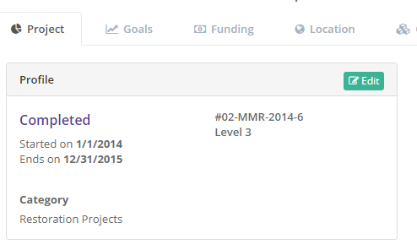

Closing out a project in HWS
UCSRB requires all project sponsor to update their information in the HWS database once the project is completed. This is a critical step in the process. Specific information is required by the region but you are welcome to fill out any information your find useful for sharing project information. Below is the list of required metrics and information and a checklist of required data for completed projects.
- Project Information (main project tab)
  - Profile- Status, correct project name and number, and start and end date
  - Photos- please upload at least one picture of your project. Before/After shots are great.
  - Summary- add a short (one paragraph) summary of your project focusing on the “What, When, Where, and Why.”
  - Map- you must add a location (point) for your project. Click the edit button, navigate to your project location and add a point. You can also add multiple locations and draw a polygon if appropriate for your project. Make sure to hit the “Save Map Position” before you exit.
- Funding Tab
  - Proposed Cost- enter a total cost
  - Sources- this is auto-populated
  - Entries- add each of your sources of funding and the amounts. Please make sure the funder is not in the drop-down list before adding a new funder! All funders and their contributions must be listed.
- Location Tab
  - This should be auto-populated if you added a point under step 3.
- Codes Tab
  - Click on the “+ Add Reporting Codes” button on the top right of the page
  - There are a number of codes listed but you can ignore most. You will need to search for the following codes to find the right ones.
  - Only the following codes are required:
    - Assessment Units
    - Activity (see table 1 below for required metrics for reporting to UCSRB, NOAA, GSRO, and PCSRF). This is one of the most important pieces of information we gather and use. Each project type has several codes it MUST report. To get to the link of Activities just search for “Activity-“ (NOT ACTIVITY TYPE!!!) and it will give you the correct list to choose from. Then add each of the required codes and hit save. **Design and assessment projects do not need to report codes.
    - Primary Ecological Concerns- choose ONLY ONE! You will have a chance to enter secondary ones. **Only restoration projects must report ECs.
    - Secondary Ecological Concerns- list only the most important secondary ECs. **Only restoration projects must report ECs
    - UC Primary Species Benefiting- Make sure you use the “UC” list. The general “Primary Species Benefitting does not call out Spring Chinook from Chinook”. Choose ONLY ONE! You will have a chance to enter secondary ones.
    - Secondary Species Benefiting- list only the most important secondary species.
- Attachments Tab
  - You can upload design reports, reports, or anything else important to the project under this tab.
- People and Organizations Tab
  - Project Contact- Please add a project contact in case we need more information.
  - Funding Source- this is auto-populated from the funding page.
  - Grant Manager- not required
  - Partner- please list all partner organizations. Make sure the organization’s name is not in the drop-down list before adding a new organization- most are in there!
  - Sponsor- please add the primary sponsor organization- LIST ONLY ONE and name other partners separately.
- Related Items Tab
  - Related Projects- is there are project related to yours (e.g. a design project) please link it here.
 | UC Project Close-Out Checklist
 | TAB | ITEM | DESCRIPTION
 | Project | Profile | Name, number, Status (Closed), and start and end dates
 | Project | Photos
 | Project | Map | One point per project
 | Project | Summary
 | Funding | Proposed Cost | Total cost of project
 | Funding | Funders and Amounts | Link to PRISM if appropriate
 | Codes | Activity Type and Metrics | See table below for required metrics
 | Codes | Assessment Units
 | Codes | Primary Ecological Concerns
 | Codes | Secondary Ecological Concerns
 | Codes | UC Primary Species Benefitting
 | Codes | Secondary Species Benefitting
 | People | Project Contact
 | People | Partners
 | People | Sponsor

Reporting in HWS
There are two great training videos on reporting project information from HWS:
Reporting Introduction- http://waconnect.paladinpanoramic.com/File/10/25191
Reporting- Creating Express Report- http://waconnect.paladinpanoramic.com/File/10/25190
Contact Greer Maier (greer.maier@ucsrb.org) for more information about reporting.
Additional References Materials and Training Videos
http://hws.ekosystem.us/resources
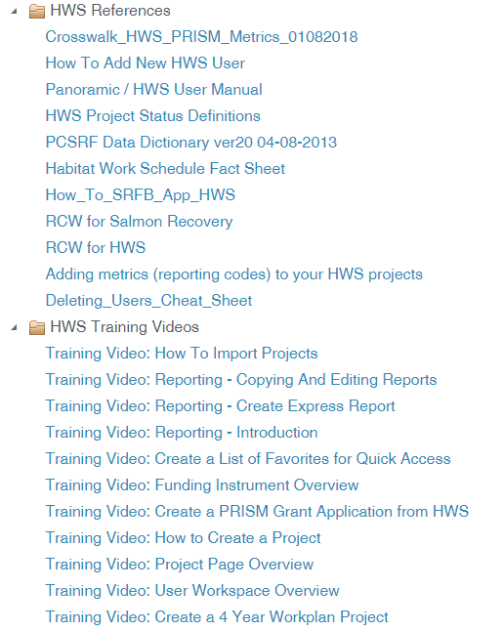

Table 1. Activity Types. Activity should reflect the primary goal of the project. Reporting Codes in bold are REQUIRED.
Activity Type (Metrics) Reference Table

Activity Type | Reporting Code | Unit | Description
Design, Monitoring or Assessment | NO REPORTING CODES REQUIRED
Acquisition, Easements, Leases | Floodplain Areas Protected | Acres | Floodplain areas acquired/protected.
Acquisition, Easements, Leases | Land, wetland or estuarine area protected from degradation or development* | Acres | Land, wetland or estuarine area protected from further degradation or development through purchase, lease, negotiated agreement, or other mechanism. The acreage reported should be the total acreage protected regardless of whether all the habitat is applicable to the desired goals for acquisition.
Acquisition, Easements, Leases | Streambank or riparian protected* | Miles | Miles of streambank protected by acquisition, easement or lease.
Fish Passage | Fish passage blockages removed or altered* | Qty. | Anadromous salmonid passage blockages, impediments or barriers that are removed or altered to allow or improve passage.
Fish Passage | Miles upstream made accessible* | Miles | Total length of potential anadromous salmonid bearing stream made accessible upstream of the passage impediment. If there is another barrier upstream, then the length made accessible would be to that next upstream barrier.
Fish Passage | Road - crossing removal: number removed | Qty. | Removal of stream road crossing and the affiliated road structures so that the stream flows unimpeded. This would include removal of culverts and other material in the channel
Fish Screen | Fish screens installed or modified* | Qty. | Number of screens installed, replaced, repaired or modified.
Instream Flow | Change in water flow | CFS | Estimated change (increase) in flow of water in the stream as a result of conservation effort.
Instream Flow | Miles of stream protected for adequate flow* | Miles | Length of potential anadromous salmonid bearing stream that is intended to have sufficient water flow for spawning and rearing (i.e., 'protected' for adequate flow) as a result of decreased/eliminated water withdrawals or reduced future water withdrawals. NOTE: please indicate the number of miles where flow is improved as a result of the project even if it is still not considered “adequate” flow.
Instream Flow | Cfs (Cubic Feet Per Second) of water conserved per year | CFS | Purchase of water rights. These water allocations are not withdrawn from the stream. (Water volumes proposed and actually leased or purchased should be reported in CFS to nearest 0.01 CFS.)
Instream Habitat  (NOTE: also includes Floodplain and Off-Channel Reconnection Projects) | Beaver introduction | Qty. | Introduction or management of beavers to add natural stream complexity (beaver dams, ponds, etc). (# of beavers introduced to increase instream structure/ complexity.)
 | Acres of channel/off-channel connected or added* | Acres | Acres of channel/off-channel connected or added. NOTE: Please use this metric for floodplain acres re-connected.
 | Miles off-channel stream created* | Miles | Channel reconfiguration and connectivity: off-channel stream created
 | Number of structures placed in channel | Qty. | Number of structures placed in channel
 | Streambank stabilization | Miles | Stabilization of the streambank through resloping and/or placement of rocks, logs, or other material on streambank.
 | Total length of instream habitat treated* | Miles | Total length of stream treated. This is a meander measurement of the portion of stream treated by the project. Multiple treatments in the same stretch of stream would only be counted once, so that the total reflects actual stream length subjected to treatments regardless of how many different treatments were applied.
Riparian Habitat | Fencing: miles installed | Miles | Creation of livestock exclusion or other riparian fencing.
Riparian Habitat | Forestry practices/stand management | Acres | Treatment or management of trees and undergrowth in riparian area including prescribed burnings, stand thinning, stand conversions, and silviculture.
Riparian Habitat | Planting | Acres | Establish riparian or native planting.
Riparian Habitat | Total riparian area treated: acres* | Acres | Total acres of streambank riparian area treated and total amount of riparian area treated or managed. Report the actual length of streambank riparian area treated, adding lengths of treatment on both sides of stream if treatment was on both streambanks.
Riparian Habitat | Total riparian area treated: acres | Miles | Total length of streambank riparian area treated and total amount of riparian area treated or managed. Report the actual length of streambank riparian area treated, adding lengths of treatment on both sides of stream if treatment was on both streambanks.
Upland Habitat | Erosion control structures: number | Qty. | Closure (abandonment), relocation, decommissioning or obliteration of existing roads to diminish sediment transport into stream. These roads may extend into or be located in the riparian zone.
Upland Habitat | Road abandonment and obliteration | Miles | Closure (abandonment), relocation, decommissioning or obliteration of existing roads to diminish sediment transport into stream. These roads may extend into or be located in the riparian zone.
Upland Habitat | Road drainage system improvements and reconstruction | Miles | Road projects that reduce or eliminate sediment transport into streams. This includes placement of structures to contain/ control run-off from roads, road reconstruction or reinforcement, surface and peak-flow drainage improvements, and roadside vegetation. These roads may extend into or be located in the riparian zone.
Upland Habitat | Slope stabilization | Acres | Implementation of slope/hillside stabilization or slope erosion control methods including landslide reparation and non-ag terracing.
Upland Habitat | Total acres of upland habitat treated* | Acres | Total amount of upland habitat treated.
Upland Habitat | Upland livestock management | Acres | Upland livestock management action designed to control sediment flow into a stream or riparian area. This includes livestock watering schedules; grazing management plans; upland exclusion and fencing; and, livestock water development (also called off-channel watering or livestock water supply) including installation of upland ditches, wells, and ponds.
Water Quality | Nutrient enrichment: miles treated | Miles | Carcasses, fish meal bricks, analog or other fertilizer placed in/along stream,
Water Quality | Total amount of water treated* | Acre Feet | Total amount of water treated for water quality.
Water Quality | Toxin reduction | Acres | Clean-up or prevention of mine tailings, herbicides, pesticides, or toxic sediments.
Wetlands | Wetland improvement/enhancement* | Acres | Improvement, reconnection, or restoration of existing or historic wetland (other than vegetation planting or removal

Table 4. Ecological Concerns. The EC category should reflect the primary goal of the project.
Ecological Concerns Reference Table

EC# | Ecological Concern Category | Ecological Concern Sub-Category
1 | Habitat Quantity | Anthropogenic Barriers
1 | Habitat Quantity | HQ-Competition
1 | Habitat Quantity | Natural Barriers
2 | Injury and Mortality | Altered Prey Species Composition and Diversity
2 | Injury and Mortality | Contaminated Food
2 | Injury and Mortality | Food-Competition
2 | Injury and Mortality | Mechanical Injury
2 | Injury and Mortality | Pathogens
2 | Injury and Mortality | Predation
3 | Food | Altered Primary Productivity
4 | Riparian Condition | Large Wood Recruitment
4 | Riparian Condition | Riparian Vegetation
5 | Peripheral and Transitional Habitats | Estuary Conditions
5 | Peripheral and Transitional Habitats | Floodplain Condition
5 | Peripheral and Transitional Habitats | Nearshore Conditions
5 | Peripheral and Transitional Habitats | Side Channel and Wetland Conditions
6 | Channel Structure and Form | Bed and Channel Form
6 | Channel Structure and Form | Instream Structural Complexity
7 | Sediment Conditions | Decreased Sediment Quantity
7 | Sediment Conditions | Increased Sediment Quantity
8 | Water Quality | Gas Saturation
8 | Water Quality | Oxygen
8 | Water Quality | pH
8 | Water Quality | Salinity
8 | Water Quality | Temperature
8 | Water Quality | Toxic Contaminants
8 | Water Quality | Turbidity
9 | Water Quantity | Altered Flow Timing
9 | Water Quantity | Decreased Water Quantity
9 | Water Quantity | Increased Water Quantity
10 | Population Level Effects | Demographic Changes
10 | Population Level Effects | Life History Changes
10 | Population Level Effects | Reduced Genetic Adaptivity
10 | Population Level Effects | Small Population Effects

